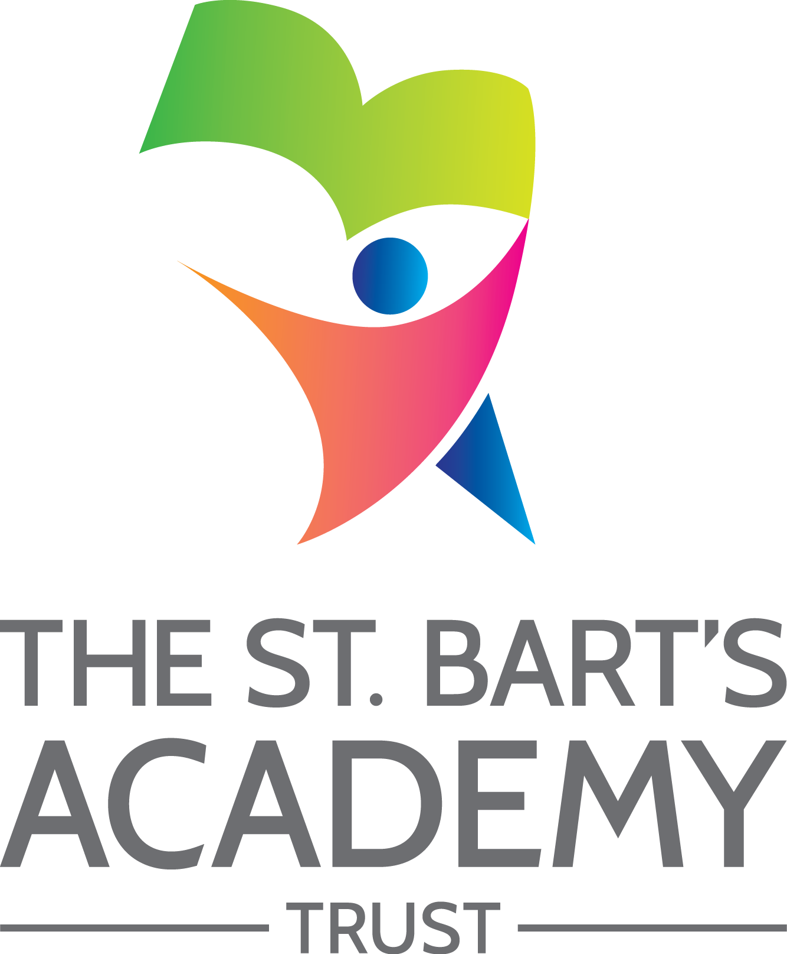

Equality
Policy

September 2023

The St. Bart’s Academy Trust
Equality Policy
Produced Date: |  | September 2023
Approved by Trust Board: |  | 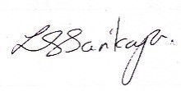 | Lisa Sarikaya  Chief Executive Officer
Review Date: |  | September 2027
Date | Section Amended |  |  | Signature

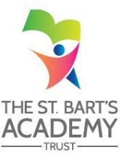

Contents

1. St. Bart’s Mission 4
2. St. Bart’s Vision and Values 4
3. Legal framework 4
4. Academy Responsibilities 5
5. Guiding principles 5
Principle 1: All learners are of equal value 5
Principle 2: We recognise and respect difference 6
Principle 3: We foster positive attitudes and relationships 6
Principle 4: We observe good equalities practice in staff recruitment 6
Principle 5: We aim to reduce and remove inequalities and barriers 6
Principle 6: We consult and involve widely 7
Principle 7: Society as a whole should benefit 7
Principle 8: We base our practices on sound evidence 7
Principle 9: Objectives 7
6. Implementation 7
7. Curriculum 7
8. Ethos and organisation 7
9. Roles and responsibilities 8
10. Religious observance 8
11. Staff development and training 8
12. Monitoring and evaluation 8

- St. Bart’s Mission
Our moral purpose is to provide the best education and curriculum in all our academies, enabling every child to realise their full potential.

- St. Bart’s Vision and Values
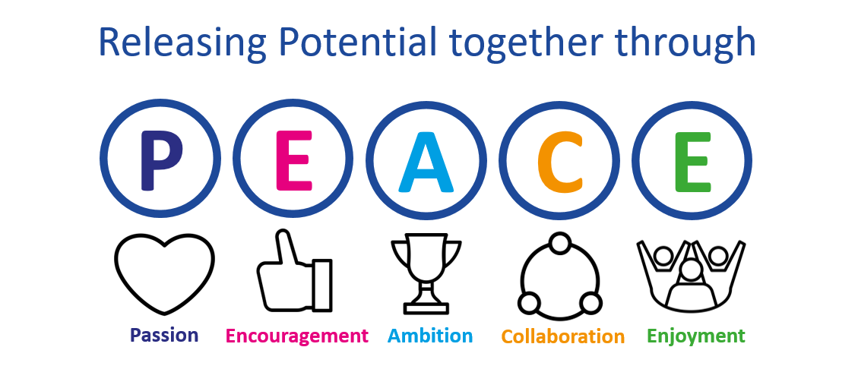

We have a Passion for releasing potential in all our children and staff through the Encouragement and development of Ambition, aspiration and excellence in all aspects of our work. Our commitment is to place children at the centre of everything we do. Working in Collaboration, we strive to provide the highest quality of educational experiences and outcomes for young people in an inclusive environment. Through the Enjoyment of learning, we live life together in all its fullness through PEACE.
We believe this vision empowers children with the skills to make a positive impact on the future of the communities they serve.
Our Trust Christian ethos is also captured by the PEACE values and all schools work in close partnership (whether C of E or community) to ensure that all children, adults and the communities they serve flourish just as Jesus encouraged us to do in John 10:10 –
“I have come that they may have life, and have it to the full.”

- Legal framework
St Bart’s Multi-Academy Trust (SBMAT) welcomes its duties under the Equality Act 2010 to eliminate discrimination, advance equality of opportunity and foster good relations in relation to any of the nine protected characteristics.
We appreciate our duty under the Education and Inspections Act 2006 to promote community cohesion. We recognise these duties are essential and that they reflect international human rights standards as expressed in the UN Convention on the Rights of the Child, the UN Convention on the Rights of People with Disabilities, and the Human Rights Act 1998.
The Trust recognises that the Equality Act 2010 introduced a single Public Sector Equality Duty (PSED) (sometimes also referred to as the ‘general duty’) that applies to public bodies, including maintained schools and academies, and extends to certain protected characteristics - race, disability, sex, age, religion or belief, sexual orientation, pregnancy and maternity and gender reassignment. This combined equality duty has three main elements. In carrying out their functions, public bodies are required to have due regard to the need to:
- Eliminate discrimination and other conduct that is prohibited by the Act,
- Advance equality of opportunity between people who share a protected characteristic and people who do not share a protected characteristic.
- Foster good relations across all characteristics - between people who share a protected characteristic and people who do not share a protected characteristic.

Having due regard for advancing equality involves:
- Removing or minimising disadvantages suffered by people due to their protected characteristics.
- Taking steps to meet the needs of people from protected groups where these are different from the needs of other people.
- Encouraging people from protected groups to participate in public life or in other activities where their participation is disproportionately low.

Additionally, specific guidance for academies is set out in the DfE publication “The Equality Act 2010 and Schools. Departmental advice for school leaders, school staff, governing bodies and local authorities” issued in May 2014.
This policy should be read in conjunction with the SBMAT Staff Equality, Equity, Diversity and Inclusion Policy.

- Academy Responsibilities
Specifically, in order to help our academies meet the general equality duty, there are two duties that they are required to carry out. These are:
- To publish information to demonstrate how they are complying with the equality duty.
- To prepare and publish specific and measurable equality objectives.
Each of our academies will therefore identify and publish on their website:
- An annual Equalities Statement and therefore fulfil the ‘Specific Duty’ to publish information to demonstrate compliance with the Equality Duty responsibilities.
- Equality Objectives - Specific, Measurable, Achievable, Relevant and Time-bound (SMART) objectives directly related to national or local evidence of any issues relating to the performance of individuals with protected characteristics. These objectives will relate to periods of up to four years and will be reviewed annually by the Principal and their senior leaders within the context of the academy’s overall performance planning, monitoring and evaluation cycle.
- Additionally, each of our academies will also publish an annual progress report of activities carried out in the year to comply with the requirements of the Equality Duty (e.g. this might include staff, governor, pupil training and awareness, specific local projects or educational interventions, etc.).

- Guiding principles
In fulfilling these legal obligations, we are guided by nine principles:

Principle 1: All learners are of equal value
We see all learners and potential learners, and their parents and carers, as of equal value:
- whether or not they are disabled
- whatever their ethnicity, culture, national origin or national status.
- whatever their gender and gender identity.
- whatever their religious or non-religious affiliation or faith background.
- whatever their sexual identity.

Principle 2: We recognise and respect difference
Treating people equally, (Principle 1 above) does not necessarily involve treating them all the same. Our policies, procedures and activities must not discriminate but must nevertheless take account of differences of life-experience, outlook and background, and in the kinds of barrier and disadvantage which people may face, in relation to:
- disability, so that reasonable adjustments are made.
- ethnicity, so that different cultural backgrounds and experiences of prejudice are recognised.
- gender, so that the different needs and experiences of girls and boys, and women and men, are recognised.
- religion, belief or faith background.
- sexual identity.

Principle 3: We foster positive attitudes and relationships, and a shared sense of cohesion and belonging
We intend that our policies, procedures and activities should promote:
- positive attitudes towards disabled people, good relations between disabled and non-disabled people, and an absence of harassment of disabled people.
- positive interaction, good relations and dialogue between groups and communities different from each other in terms of ethnicity, culture, religious affiliation, national origin or national status, and an absence of prejudice related bullying and incidents.
- mutual respect and good relations between boys and girls, and women and men, and an absence of sexual and homophobic harassment.

Principle 4: We observe good equalities practice in staff recruitment, retention and development
We ensure that policies and procedures should benefit all employees and potential employees, for example in recruitment and promotion, and in continuing professional development:
- whether or not they are disabled.
- whatever their ethnicity, culture, religious affiliation, national origin or national status.
- whatever their gender and sexual identity, and with full respect for legal rights relating to marriage, civil partnerships, pregnancy and maternity.

Principle 5: We aim to reduce and remove inequalities and barriers that already exist
In addition to avoiding or minimising possible negative impacts of our policies, we take opportunities to maximise positive impacts by reducing and removing inequalities and barriers that may already exist between:
- disabled and non-disabled people.
- people of different ethnic, cultural and religious backgrounds.
- people of different Gender identity or expression of gender identity
- Age of different pupils

Principle 6: We consult and involve widely
We engage with a range of groups and individuals to ensure that those who are affected by a policy or activity are consulted and involved in the design of new policies, and in the review of existing ones.

Principle 7: Society as a whole should benefit
We intend that our policies and activities should benefit society as a whole, both locally and nationally, by fostering greater social cohesion.

Principle 8: We base our practices on sound evidence
We maintain and publish quantitative and qualitative information about our progress towards greater equality.

Principle 9: Objectives
We formulate and publish specific and measurable objectives, based on the evidence we have collected and published (Principle 8) and the engagement in which we have been involved (Principle 6).

- Implementation
We recognise that the actions resulting from a policy statement such as this are what make a difference.
Every four years, accordingly, the Trust and each Academy will establish equality objectives it will pursue. The objectives which we identify take into account national and local priorities and issues, as appropriate.
The Trust / each Academy will keep its equality objectives under review and report annually on progress towards achieving them to the Trust Board / Local Governing Committee.

- Curriculum
All academies keep each curriculum subject or area under review in order to ensure that teaching and learning reflect the nine principles set out in paragraph 3 above. We are committed to having a balanced, diverse and fair curriculum. We believe that our pupils should be exposed to ideas and concepts that may challenge their understanding, to help ensure that pupils learn to become more accepting and inclusive of others.

- Ethos and organisation
We ensure the principles listed in paragraph 3 above apply to the full range of our policies and practices, including those that are concerned with:
- pupils' progress, attainment and achievement
- pupils' personal development, welfare and well-being
- teaching styles and strategies
- admissions and attendance
- staff recruitment, retention, performance review and professional development
- behaviour, discipline and exclusions
- working in partnership with parents, carers and guardians
- working with the wider community
Children and all staff are encouraged to value each other and build up and maintain cooperative working relationships both within the academy and in the community, such relationships being based on mutual respect for each other.

- Roles and responsibilities
The Trust Board is responsible for approving this policy. The Local Governing Committee is responsible for ensuring that the individual academy complies with legislation, and that this policy and its related procedures, statements and objectives are implemented.
A senior member of staff has day-to-day responsibility for co-ordinating implementation of the policy.
All staff are expected to:
- Lead by example
- promote an inclusive and collaborative ethos in their classroom and across the academy
- deal with any prejudice-related incidents that may occur
- plan and deliver curricula and lessons that reflect the principles above
- support pupils in their class for whom English is an additional language
- keep up-to-date with equalities legislation relevant to their work.
We ensure that the content of this policy is known to all staff and governors and, as appropriate, to all pupils and their parents and carers. All staff have access to a selection of resources which discuss and explain concepts of equality, diversity and community cohesion in appropriate detail.

- Religious observance
We respect the religious beliefs and practice of all staff, pupils and parents, and comply with reasonable requests relating to religious observance and practice. See SBMAT Religious Observance Guidance.

- Staff development and training
We ensure that all staff, including support and administrative staff, receive appropriate training and opportunities for professional development, both as individuals and as groups or teams.

- Monitoring and evaluation
This policy will be reviewed by the Trust at least every 4 years.

St. Bart’s Multi-Academy Trust
c/o Belgrave St. Bartholomew’s Academy,
Sussex Place, Longton, Stoke-on-Trent, Staffordshire, ST3 4TP
www.sbmat.org T: 01782 486350

