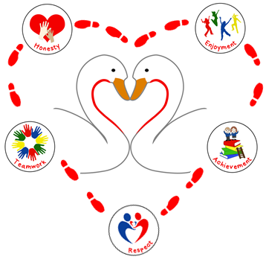



Pupil and Parent Acceptable Use Policy.

**Date: September 2022**

**Review: September 2023**

Continuing The Learning Journey Together

Social Media Policy

**Parents and Pupils Acceptable Use Policy - Protecting the Park Hall Family**

Introduction

The Internet is an essential element in 21st century life in education, business and social interaction. We have a duty to provide pupils with quality internet access to enhance their learning experience. As we have a responsibility to teach pupils and their families about acceptable use of the Internet, this agreement sets out clear objectives for online communications and the measures that we have taken to minimise the potential risks posed by technology. ICT equipment including IPads are provided for the benefit of all in the learning community, and help deliver improvements in teaching and learning. Access to the facilities is a privilege and not a right. There are some basic rules that staff and learners need to follow, to ensure that everyone in the school community can benefit from these facilities.

Park Hall Academy will:

* Regularly monitor system security, ensuring that up-to date virus protection is installed on every computer, as well as forensic software.
* Ensure that children understand the importance of strong passwords and the importance of protecting passwords.
* Supervise pupils when using approved email accounts to ensure that communications are respectful.
* Supervise video conferencing activities.
* Supervise pupil’s use of the Internet.
* Provide a child friendly e-safety policy to ensure that children are all aware of our expectations for responsible online behaviours. Pupils are required to agree to adhere to these expectations and sign to indicate their understanding.
* Embed E-safety into the computing curriculum and ensure pupils are demonstrating all e-safety aspects taught when using technology.
* Not publish pupil’s full names in online communications.
* Seek permission from parents and carers prior to publishing children’s work online.
* Take all reasonable precautions to ensure that users access only appropriate material however, due to the international scale and linked nature of Internet content, it is not possible to guarantee that unsuitable material will never appear on a school computer. Neither the academy nor the St. Bart’s Multi Academy Trust can accept liability for the material accessed, or any consequences of material accessed.
* Promote fundamental British Values and seek to ensure that all online communications are in-line with these.

Children Will:

* Agree to adhere to the academy child friendly e-safety policy which states that they will:
* Demonstrate in their online activities the academy values that are at the heart of everything that we do. (Honesty, Enjoyment, Achievement, Respect and Teamwork)
* Show respect – ‘tweet others the way you would like to be tweeted.’
* Use the internet with an adult’s permission.
* Use the internet safely to search for educational information.
* Use a strong password and not tell anyone else what that password is.
* Remember that not everyone online is who they say they are.
* Remember E-safety lessons I have been taught and demonstrate a safe approach to using technology.
* Always be friendly and polite when communicating with others.
* Not damage or break IT equipment, either on purpose or by being careless. This includes not eating or drinking near IT equipment.
* Always lock computer or IPads when you are away from your workspace, to prevent others accessing your files and information.
* Not install any software or extra hardware (printers, scanners, mice, speakers) unless you have first checked with the ICT department. This is particularly important for apps, as they may have wide ranging permissions that compromise the security of your machine and the ICT network as a whole.

We recognise that as a child’s learning journey progresses, then so does their access to a wider range of technologies. Their level of awareness and engagement in the use of technologies enables them to further develop their independent and creative use of these technologies. As a result, our children understand that the academies expectations of them develop to reflect their growing skills, knowledge and understanding. Our Pupil’s Acceptable Use Policy Agreement is therefore progressive.

Pupils in Early Years Foundation Stage and Key Stage 1 Acceptable Use Policy Agreement:

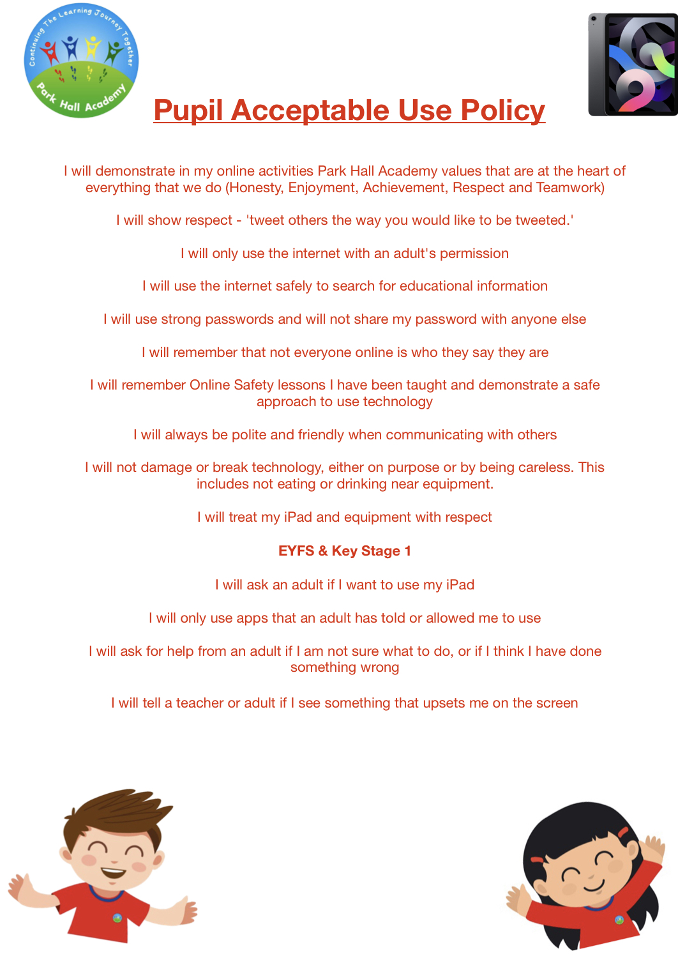This is how we stay safe when we use computers:

* I will ask an adult if I want to use the computers/iPads
* I will only use activities that a teacher or suitable adult has told or allowed me to use.
* I will take care of the computer and other equipment
* I will ask for help from a teacher or adult if I am not sure what to do, or if I think I have done something wrong.
* I will tell a teacher or adult if I see something that upsets me on the screen.

I know that if I do not follow these expectations, I might not be allowed to use a computer or my IPad.

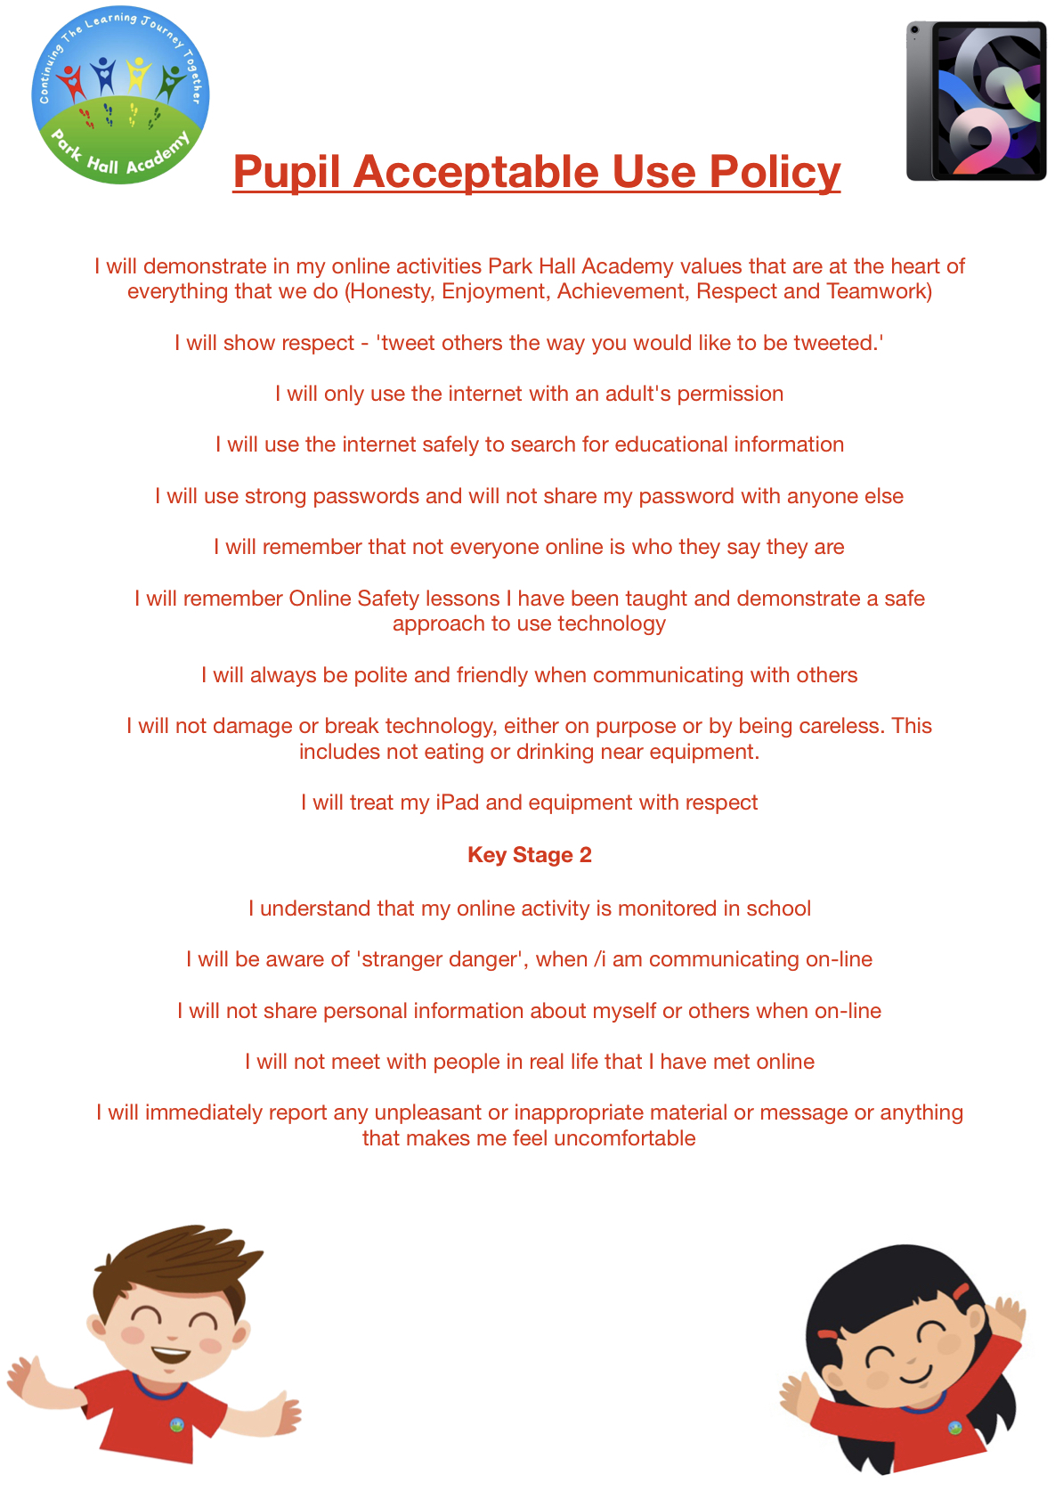Pupils in Key Stage 2 Acceptable Use Policy Agreement:

I understand that I must use academy technologies in a responsible way, to ensure that there is no risk to my safety or to the safety and security of the systems and other users.

For my own personal safety:

• I understand that the academy will monitor my use of technologies.

• I will keep my username and password safe and secure – I will not share it, nor will I try to use any other person’s username and password. I understand that I should not write down or store a password where it is possible that someone may steal it.

• I will be aware of “stranger danger”, when I am communicating on-line.

• I will not disclose or share personal information about myself or others when on-line (this could include names, addresses, email addresses, telephone numbers, age, etc.)

• I will not meet with people in real life that I have met online.

• I will immediately report any unpleasant or inappropriate material or messages or anything that makes me feel uncomfortable when I see it on-line to an adult.

I know that if I do not follow these expectations, I might not be allowed to use a computer or my IPad.

I understand that everyone has equal rights to use technology as a resource and:

• I understand that the academy technologies are intended for educational use and that I will not use them for any other purpose unless I have permission.

• I will not download or upload files without permission

• I will not use the academy computers or iPads for on-line gaming, file sharing, or video broadcasting (e.g. You Tube), unless I have the permission of a member of staff.

I will act as I expect others to act toward me: “Tweet Others The Way I Would Like To Be Tweeted”.

• I will not access, copy or remove others files, without their knowledge and permission.

• I will be polite and responsible when I communicate with others.

• I will not take or distribute images of anyone without their permission.

I recognise that the academy has a responsibility to ensure the technology we use is safe and in good working order

* I will not use my own personal devices (mobile phones / USB devices etc.) in school without speaking to a member of staff.
* I understand the risks and will not try to upload, download or access any materials which are illegal or inappropriate or may cause harm or distress to others.
* I understand that my activities on line are monitored by forensic software to keep me safe and that Senior Leaders can see all of my online activities.
* I will immediately report any damage or faults involving equipment or software, however this may have happened.
* I will not open any hyperlinks in emails or any attachments to emails, unless I know and trust the person who sent the email.

• I will not install or attempt to install apps on the iPads.

• I will only use social media sites with the expressed permission of the teacher when the use of social media is part of the learning objectives.

* I will not connect mobile equipment to the network, always ask ICT staff to help so that it is done safely and that your equipment can be virus checked and protected. Please note that is the equipment does not have anti-virus software installed then ICT staff will not add it to the network.

When using the internet I recognise that:

* Staff and learners are encouraged to explore the internet and use a range of resources for teaching and learning. This should be done in a responsible way, and with an open-mindedness to new ideas and new ways of thinking.
* Rules about internet use apply equally to all staff and learners. This helps to promote shared values within the school, and to promote shared learning.
* Network filtering is in place to prevent access to inappropriate sites, and there is keyword logging software that flags certain terms.
* I need to notify ICT staff immediately if I access any inappropriate sites by accident, or if I find inappropriate content on a workstation or the internet.
* I must use the internet in accordance with UK law. Any illegal use will be dealt with through official channels, which may include the involvement of police if a crime has been committed.

I understand that I must uphold British Values:

* The following are fundamental British Values:
  + democracy, (everyone having a voice)
  + rule of law, (abide by laws)
  + individual liberty, (everyone has a right to their own views)
  + mutual respect and tolerance for those with different faiths and beliefs
* I must not engage in any communications which may be at odds with fundamental British Values.
* I must respect views which may differ from my own.

I understand that I am responsible for my actions, both in and out of school:

• I understand that the academy also has the right to take action against me if I am involved in incidents of inappropriate behaviour, that are covered in this agreement, when I am **out of school** (examples would be cyber-bullying, use of images or personal information).

• I understand that if I fail to comply with this Acceptable Use Policy Agreement, consequences may include loss of access to the academy network/internet, suspensions or exclusions, contact with parents and in the event of illegal activities involvement of the police.

Parents will:

* Work in partnership with the academy to ensure that we work together to protect all members of the Park Hall family.
* Model the values that we expect our children to demonstrate by showing respect and consideration for all members of the Park Hall family.
* Agree to the acceptable use policy for parents and pupils (this must be signed before pupils are granted Internet access).
* Directly supervise children when they are using the Internet outside of school, in order to ensure that children consistently demonstrate safe and respectful practises online.
* Ensure that pupils do not bring a mobile phone into our academy or any other technology which allows photographs to be taken on the school premises, without permission from the Principal.
* Parents/Carers/family members must not post images of pupils, other than their own children on social media sites where these images have been taken at school events.
* **Agree to respect the privacy of the school community (children, staff, governors, other parents and any other stakeholders) when publishing material online, particularly where there may be issues of data and confidentiality.**
* Agree not engage in online discussion on personal matters relating to members of the school community or the setting’s activities in any negative context, and/or actions that may bring an individual, profession or setting’s reputation into disrepute

Parents can seek further guidance on keeping children safe online from the following organisations and websites:

* What are the issues? UK Safer Internet Centre: <https://www.saferinternet.org.uk/advice-centre/parents-and-carers/what-are-issues>
* Hot topics, Childnet International: <http://www.childnet.com/parents-and-carers/hot-topics>
* Parent factsheet, Childnet International: <http://www.childnet.com/ufiles/parents-factsheet-09-17.pdf>
* Downloadable guides to help set parental controls on a range of devices: <https://www.internetmatters.org/>
* Police website for reporting e-safety concerns <https://www.ceop.police.uk/Safety-Centre/>

Non-compliance

* Incidents of inappropriate behaviour or content must be notified to the E-safety Leader who will notify the Principal as appropriate.
* In dealing with such incidents the academy will endeavour to distinguish between deliberate attempts to upset others or to breach rules and genuine mistakes.
* In the event of deliberate misuse, the e-safety leader may block unsuitable content and users may be suspended from using technology within the academy.
* Any other sanctions will be in-line with the academy promoting positive behaviours policy.

Agreement

This form must be completed and signed by all parents and carers who have parental responsibility.

* I agree to the academy Acceptable Use Policy for Parents and Pupils.
* I understand that I am responsible for supervising my child’s use of technologies and the Internet outside of school.
* I will model the values that we expect our children to demonstrate by showing respect and consideration for all members of the Park Hall family.

Monitoring and Review:

This acceptable use policy was created in collaboration with the Principal, Computing and E-Safety Governor, Computing and E-Safety Leader and the Children’s Safeguarding Board. It will be reviewed annually or in the light of new and emerging technologies.